Step 1. Go to https://online.solid.ru/login
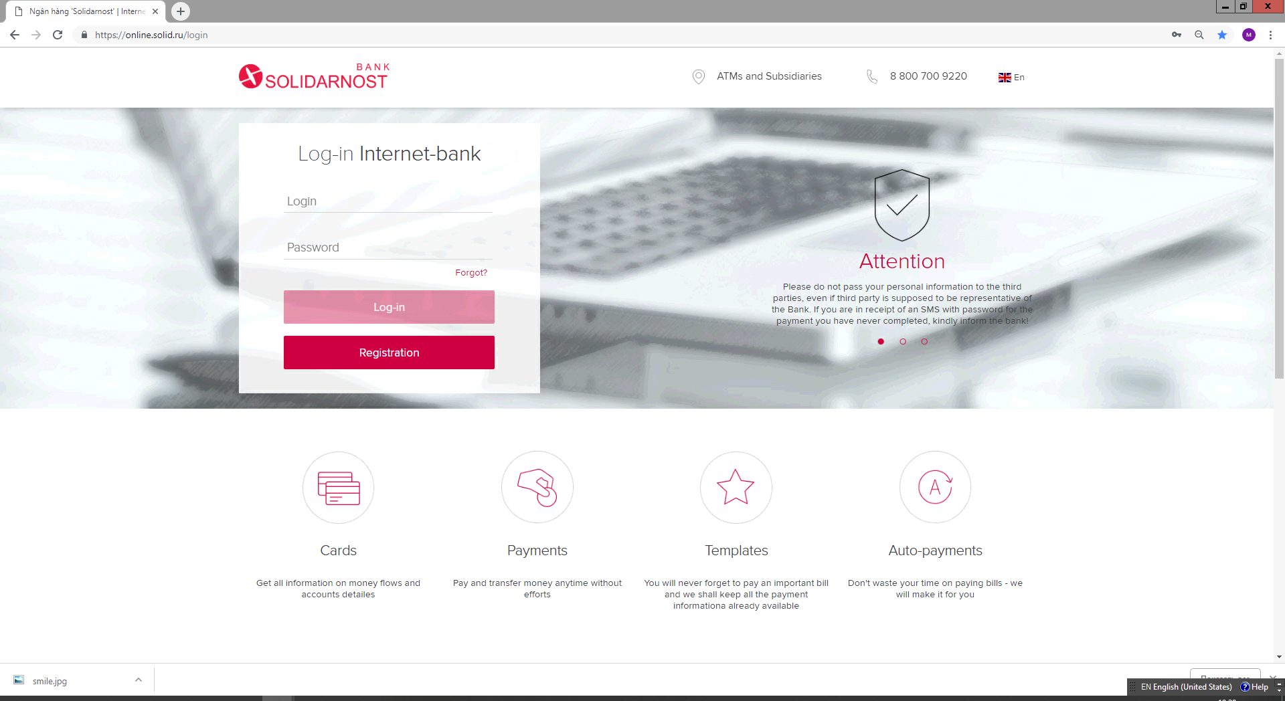

Step 2. Enter your Login and Password

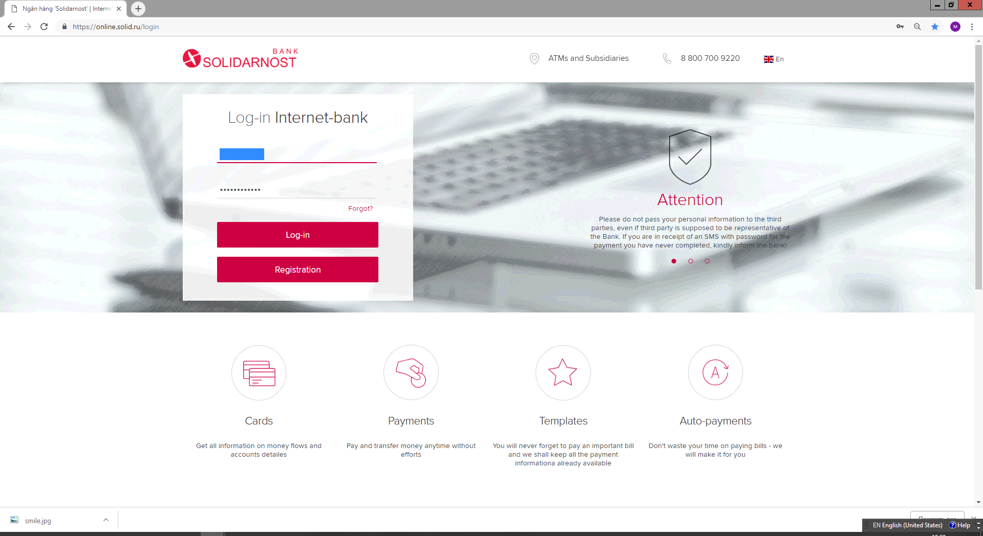

Step 3. Receive sms with a single-used Password

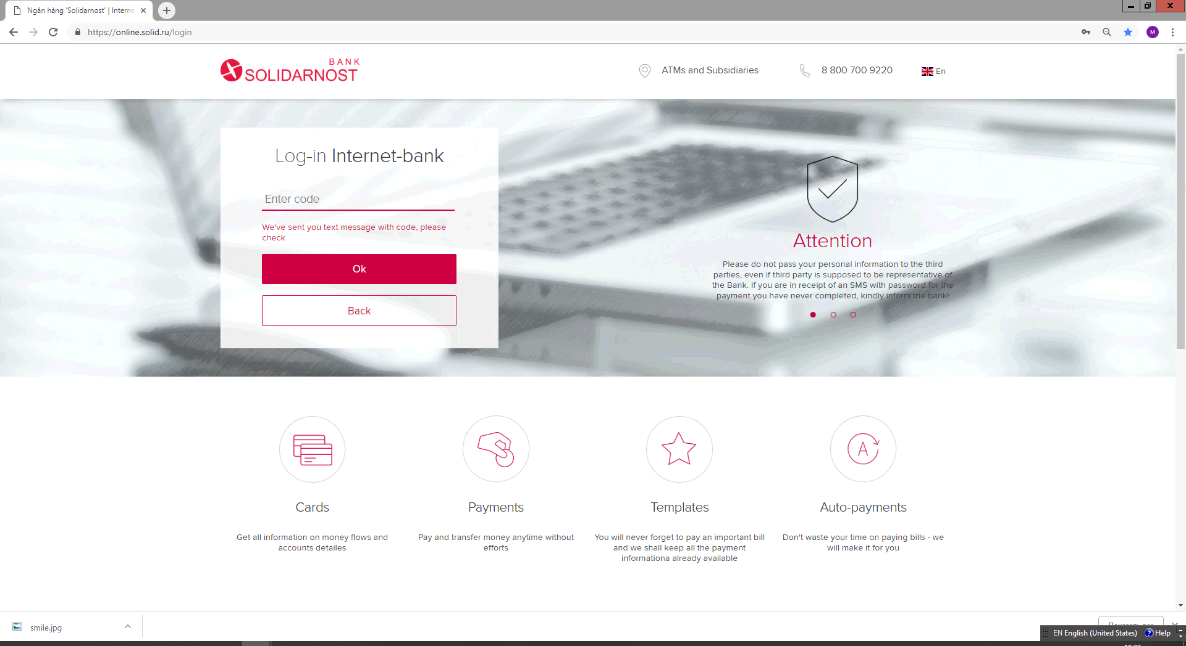
Step 4. To change Login and Password, press the “head” (right side of the yellow smiling emoji) close to Surname and Name lines.

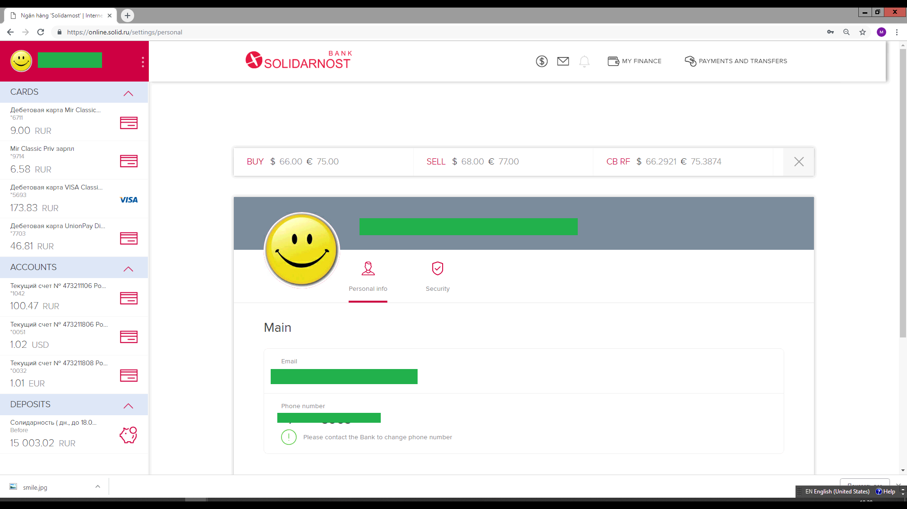

Step 5. Then go to ‘Security’ page (the shied icon) – here you can change Login and Password

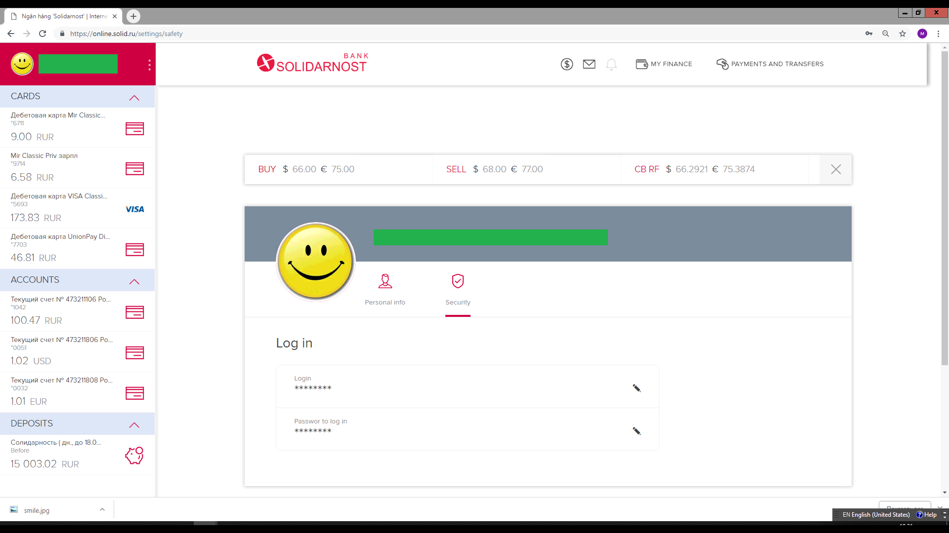

Step 6. Press pen icon and change Login (first line). Same for the Password (second line).

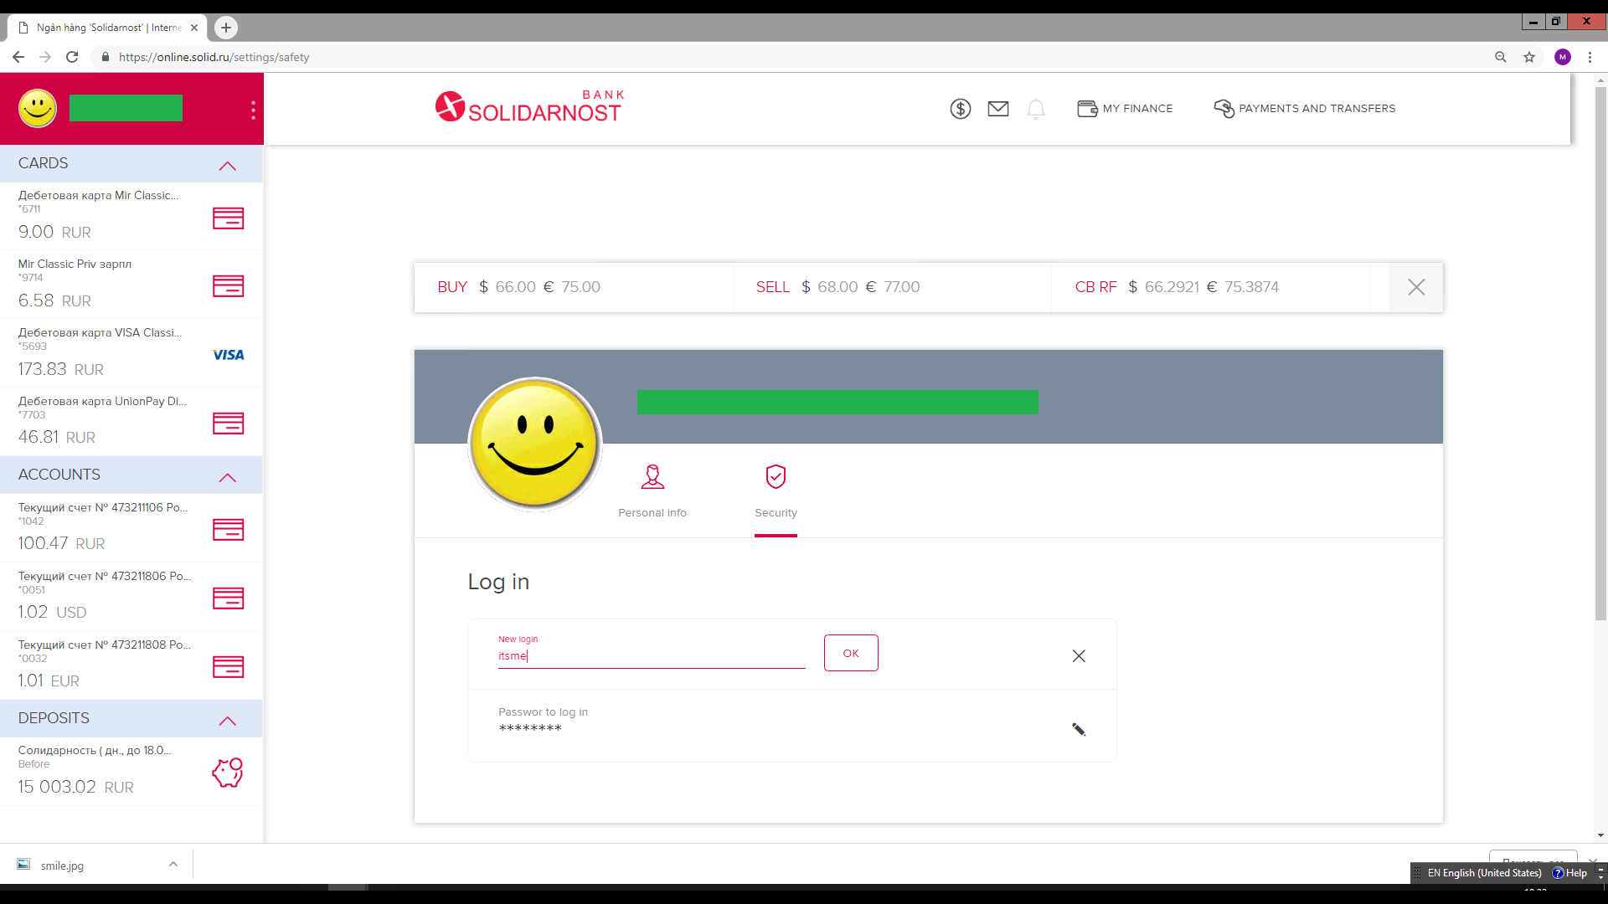

Step 7. Press pen icon and change Password.
